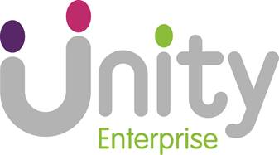

Unity Enterprise provides managed work space and support facilities for inner-city enterprise and voluntary sector organisations across Leeds. As a not for profit organisation, we provide the tools needed to encourage confidence, growth and development.

Unity Enterprise Handyperson
(25 hours per week)
£16,560 to £18,330 (pro rata)

We are looking to develop and improve the services we offer to our tenants, and have a vacancy for a handyperson with some basic administrative responsibility. You must have a commitment to service delivery and the willingness to work as part of a team.
You must be flexible and strive to provide the best possible service to a wide range of customers across any of our site locations.

Requirements:
Experience of carrying out small scale repairs and maintenance
Excellent customer service skills
Work with minimum supervision
Ability to manage a demanding workload
Physically able to bend, lift and carry
Confident to work at height

Application forms and additional information must be sourced from the uha website in the first instance
uha@unityha.co.uk - employment
For paper copies only please email ann.foster@unityha.co.uk

he closing date for applications is Tuesday 29 March 2016.Interviews will take place week commencing 4 April 2016.

Unity Enterprise manages 3 business centres within Leeds.

The closing date for applications is Friday 6 April 2018

Unity welcomes applications from all sections of the community

